TFS #99216

INC0203038, INC0203515 - Constraint Violation Error when same existing address is used multiple times

Overview

Constraint Violation error triggers when the same existing address is added multiple times on the location panel, then selected address for 1098 is subsequently deleted and re-submitted.

April Beston

11/22/2016

Table of Contents

TFS #99216 1

Description 2

Testing Notes 3

Screen Shots and Steps Taken 3

# Description

The following error triggers when the same existing address is added multiple times on the location panel, then selected address for 1098 is subsequently deleted and re-submitted.

Constraint violation. Failed to enable constraints. One or more rows contain values violating non-null, unique, or foreign-key constraints. DataSetName = BECCollateral tblAddress (RowError= 'Column 'AddressOID' is constrained to be unique. Value '0310101120-5963-0A01-A01A-0A0A0A0A0A0A' is already present.') AddressOID=0310101120-5963-0A01-A01A-0A0A0A0A0A0A (ColumnError='Column 'AddressOID' is constrained to be unique. Value '0310101120-5963-0A01-A01A-0A0A0A0A0A0A' is already present.') AddrLine1=661 Weigold Road AddrLine2= AddrLine3= ZipCodeNum=06790 ZipCodeSuffix= CityName=Torrington StateCde=9 CountyCde=306 TownCde=73 CountryCde=29990 StartResidenceDte= EndResidenceDte= RentalInd=False LandlordOID= DrivingDirectionsTxt= ForeignPostalCodeTxt= (RowError= 'Column 'AddressOID' is constrained to be unique. Value '0310101120-5963-0A01-A01A-0A0A0A0A0A0A' is already present.') AddressOID=0310101120-5963-0A01-A01A-0A0A0A0A0A0A (ColumnError='Column 'AddressOID' is constrained to be unique. Value '0310101120-5963-0A01-A01A-0A0A0A0A0A0A' is already present.') AddrLine1=661 Weigold Road AddrLine2= AddrLine3= ZipCodeNum=06790 ZipCodeSuffix= CityName=Torrington StateCde=9 CountyCde=306 TownCde=73 CountryCde=29990 StartResidenceDte= EndResidenceDte= RentalInd=False LandlordOID= DrivingDirectionsTxt= ForeignPostalCodeTxt= (RowError= 'Column 'AddressOID' is constrained to be unique. Value '0310101120-5963-0A01-A01A-0A0A0A0A0A0A' is already present.') AddressOID=0310101120-5963-0A01-A01A-0A0A0A0A0A0A (ColumnError='Column 'AddressOID' is constrained to be unique. Value '0310101120-5963-0A01-A01A-0A0A0A0A0A0A' is already present.') AddrLine1=661 Weigold Road AddrLine2= AddrLine3= ZipCodeNum=06790 ZipCodeSuffix= CityName=Torrington StateCde=9 CountyCde=306 TownCde=73 CountryCde=29990 StartResidenceDte= EndResidenceDte= RentalInd=False LandlordOID= DrivingDirectionsTxt= ForeignPostalCodeTxt= - InnerException()

AMB 11/18/16 - I was able to reproduce this error:

Steps –

1. Add the same existing address several times on the location panel

2. Select one instance of this address as primary for 1098

3. Submit Scenario, do not check "Auto-Book Now"

4. Return to the location panel for the same piece of collateral on delete the selected for 1098 instance of the address, Primary for 1098 radio button should default to top most instance of the address

5. Re-Submit scenario, this should trigger the error

See Video: <https://mysite.financialpartners.com/my/bestona/Shared%20Documents/AgC%20Test%204%20error%20conf%202.wmv>

AMB 11/18/16 - See Paul's email regarding possible information on this error: <https://mysite.financialpartners.com/my/bestona/Shared%20Documents/RE%20Possible%20to%20hold%20nightly%20for%20Lab%20G%20another%20hour.msg>

Steps:

1. Add a new location for an address

2. Submit

3. Notice the itinerary (summary of changes) shows an INSERT for Address. That's probably the source of this bug because the address row already exists in EmPOWER

4. Submit

5. Reopen the apply changes modal

6. Notice the "Address" insert is still there pending a submit (bug)

Video: <https://mysite.financialpartners.com/my/bestona/Shared%20Documents/AddressStickingInItineraryAfterSuccessfulSubmit.wmv>

AMB 11/21/16 - After initial testing of QA build on 11/21/16, I am receiving a new error when testing the steps above. See picture: <https://mysite.financialpartners.com/my/bestona/Shared%20Documents/Screen%20Shots%20and%20Videos/FCW%20New%20Error%20Post%20Build%20112116.png>    and

Video: <https://mysite.financialpartners.com/my/bestona/Shared%20Documents/Screen%20Shots%20and%20Videos/Constraint%20Error%203%20Test%20FCE%20Post%20Build%20112116.wmv>

AMB 11/22/16 – After a new build to QA on 11/21/16, Test Passed. See: Video

# Testing Notes

Steps –

1. Add the same existing address several times on the location panel

2. Select one instance of this address as primary for 1098

3. Submit Scenario, do not check "Auto-Book Now"

4. Return to the location panel for the same piece of collateral on delete the selected for 1098 instance of the address, Primary for 1098 radio button should default to top most instance of the address

5. Re-Submit scenario, this should trigger the error

See Video: <https://mysite.financialpartners.com/my/bestona/Shared%20Documents/AgC%20Test%204%20error%20conf%202.wmv>

AMB 11/21/16 - After initial testing of QA build on 11/21/16, I am receiving a new error when testing the steps above. See picture: <https://mysite.financialpartners.com/my/bestona/Shared%20Documents/Screen%20Shots%20and%20Videos/FCW%20New%20Error%20Post%20Build%20112116.png>    and

Video: <https://mysite.financialpartners.com/my/bestona/Shared%20Documents/Screen%20Shots%20and%20Videos/Constraint%20Error%203%20Test%20FCE%20Post%20Build%20112116.wmv>

AMB 11/22/16 – After a new build to QA on 11/21/16, Test Passed

## Screen Shots and Steps Taken

1. Add the same existing address several times on the location panel, and select one instance of this address as primary for 1098

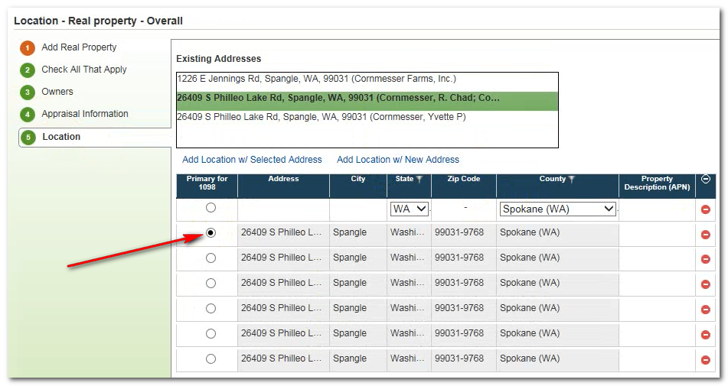

1. Submit Scenario, do not check "Auto-Book Now"

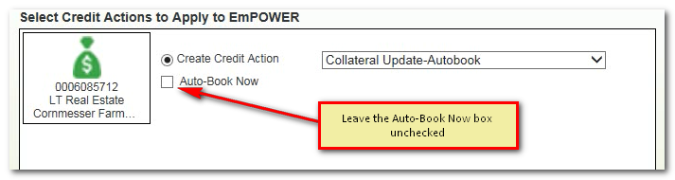

1. Return to the location panel for the same piece of collateral on delete the selected for 1098 instance of the address, Primary for 1098 radio button should default to top most instance of the address.

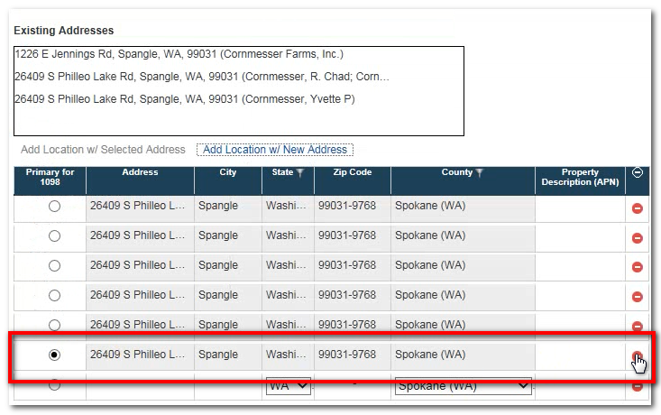

1. Re-Submit scenario. Scenario should submit without any hard errors.